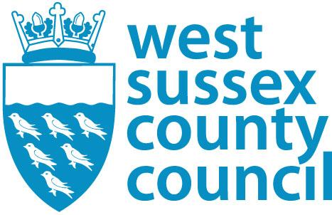

SCHOOL PLACE ACCEPTANCE
FOR The Angmering School SEPTEMBER 2024

PLEASE RETURN TO THE ABOVE NAMED SCHOOL by 1 April 2024.
Accepting the place offered does not affect your right to join a waiting list or appeal for any school you have been refused but will ensure that your child has a school place for September.

Please complete in BLOCK CAPITALS

Child’s Forename
Child’s Surname
Is the name above your child’s legal name? Yes/No
Child’s Date of Birth |  | Male/Female
Child’s Address
Current School (if applicable)

*Tick applicable box

I accept the place offered and attach a copy of my 2024/2025 Council Tax statement as required.

I do not need the place allocated as I have made the following alternative arrangements

……………………………………………………………………………………………………………………………………………………………………

If your address has or will be changing before September 2024 you must notify the Pupil Admissions Team without delay.

West Sussex County Council reserves the right to request further supporting documentation where necessary to confirm residence at the application address – places secured using false information will be withdrawn.

Your place may be offered to another child if the school does not receive this completed slip.

By signing this form I confirm that I have parental responsibility for this child and that all the information given is legal and true.
Print Name: |  | Signature:
Date: |  | Relationship to Child:
Home Tel: No: |  | Work Tel: No:
E-mail address:

