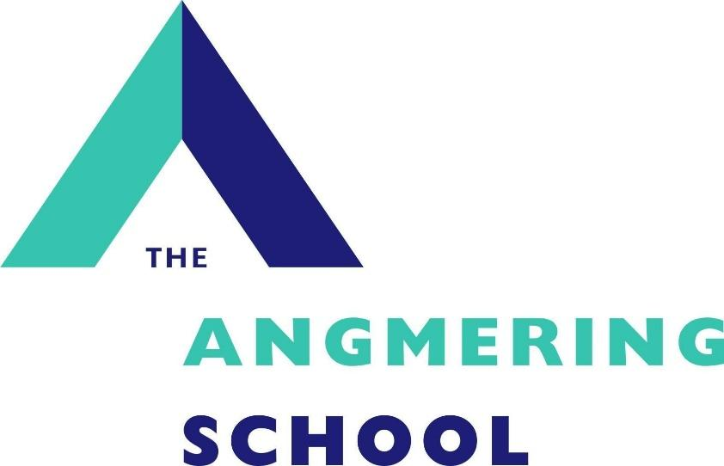

Learning Support Assistant with BSL (LNC)

Recruitment Pack

September 2026

Dear Applicant,
Thank you for your interest in this vacancy and for requesting an information pack. We hope you find the information useful. Please refer to our school website which gives further detail about our school. Please read the requirements for the application process as carefully as possible and ensure that, if you decide to submit an application, you do not omit any elements. It is essential that you use the section on page 4 of the application form to clearly demonstrate how any experience is relevant to the role and how you meet the person specification. If you would like to visit our school to get a better feel for how we operate please contact the school office to make an appointment.
We look forward to meeting you.
Yours sincerely,

Simon Liley
Headteacher

LEARNING SUPPORT ASSISTANT with BSL

Fixed Term Contract From September 2026 for one year

Salary: Grade 5/6 depending on experience, £26,403 per annum (pro rata approx. £19,980 per annum)
Working Hours: 32.5 hours per week, Monday-Friday – 8:30am-3:30pm (with a 1/2hr unpaid lunch break) Term Time Only, plus INSET days
Closing date:Tuesday 7th July 2026 Interview date:Friday 10th July 2026

The LNC is seeking to appoint an enthusiastic and dedicated learning support assistant with a minimum of BSL level 2/3 to join our inclusive team.
Working under the guidance of our leadership team, you will provide 1:1 and small
group support to Deaf and hard of hearing pupils within this school setting. Your
primary role will be to enable full access to the curriculum, facilitate communication
between pupils, peers and staff, and promote independent learning within the school
environment.

‘Staff are enthusiastic about working at the school. They are also very positive about leaders’ attention to their well-being. Leaders are considerate of staff workload.’ – Ofsted report 2022
We can offer you:
- A supportive and strong team, which recognises the importance of staff wellbeing.
- A school that has a special support centre for students with physical and sensory needs.
- A school with good transport links.

We are looking for someone who:
- You must hold a minimum BSL level 2 but ideally Level 3 qualification
- Previous experience of working with deaf children or young people in an educational or
social care setting is preferred
- Excellent communication skills, patience, and the ability to work under pressure
- A dedication to supporting the emotional, social and academic development of learners
- Is enthusiastic, proactive, resilient and resourceful
- Has good communication and organisational skills
- Feels positive about learning and working with young people with disabilities, learning and behavioural needs
- Has endless supplies of patience and the confidence to work with secondary aged students across a range of subjects
- Is able to work with students who require personal care
- Will be a pivotal part of improving opportunities for our students
- Has a passion for education
- Would like to develop their skills through CPD

Training will be given to the successful candidate

Please see our website for an application form and further details.
THE ANGMERING SCHOOL, STATION ROAD, WEST SUSSEX, BN16 4HH Tel. 01903 772351 Fax 01903 850752
e-mail recruitment@theangmeringschool.co.uk website www.angmeringschool.co.uk
The Angmering School is committed to safeguarding and promoting the welfare of children and young people and expects all staff and volunteers to share this commitment. . The post is subject to a Criminal Records Check. Only completion of all appropriate forms will be considered for short listing. In light of potentially high volume of applicants, you will only be contacted if successfully invited to interview.

JOB DESCRIPTION
Job Title: Learning Support Assistant with BSL
Accountable to: Assistant Head Teacher, SENDCo
Hours: 32.5 hours per week, Monday-Friday 8:30am – 3:30pm (with a 1/2hr unpaid lunch break)
Term Time Only, plus INSET days

Job Purpose:
To support students physical or sensory disabilities, learning, communication, emotional, social or behavioural difficulties to gain access to all aspects of education in the inclusive setting of The Angmering School.

About The Angmering School:
The Angmering School is a secondary school with 1,388 students of which 138 are in sixth form. We are effective in delivering outcomes that provide well for all students’ needs. Students are well prepared for the next stage of their education, training or employment.

Main Duties to include:
Key Responsibilities
- Use BSL to translate spoken English into BSL and vice-versa in classroom settings
- To support and develop the use of BSL for a small group of pupils
- Tailor learning materials and support classroom activities to meet pupil needs
- Facilitate communication during break times, extracurricular activities and school trips
- Liaise with teachers, leadership and external agencies
- Provide daily support for students personal care including, feeding, toileting and support in physio and hydro
Conditions for effective student learning:
- Act as Learning Support Assistant following induction into all aspects of the role
- Work with students with Special Educational Needs/disabilities in small groups or individually. Support others if time allows.
- Accompany students to lessons and support access to the lessons.

Observe students, share information within the team, record and plan for progress and complete logs.
Structures to support effective learning:
- Follow the guidelines for effective support for students
- Liaise with members of the team and subject teachers as appropriate.
- Maintain positive working relationships with parents if required.
- Implement the system for cover of students' break and lunchtime needs.
The ethos of the Curriculum Area:
- Ensure students are at the heart of everything.
- Maintain a commitment to continuous improvement.
- Attend staff development opportunities.
- Respect confidentiality.
- Be aware of and implement all aspects of safeguarding procedures.
General:
- Other general duties when required to do so by Senior Management or a member of the Headship Team.
Health and Safety:
- To be alert to the health and safety of the working environment and to advise the line manager of any health and safety concerns.
This job description is intended to convey information essential to understanding the scope of the job and the general nature and level of work performed by job holders within this role. It is not intended to be an exhaustive list of skills, efforts, or duties, associated with the position. There may be a requirement to undertake other duties reasonably required by the line manager/Head Teacher provided the task is commensurate with the post holder’s core skill competencies, knowledge and experience in the role.

This job profile recognises the demands of the current Pay and Conditions Regulations and reflects the policies established by the governors at The Angmering School.

Person Specification
Key areas: | Key attributes: | Essential or Desirable
Skills required | - Ability to act on own initiative.  - Ability to motivate and encourage students.  - Ability to observe and monitor progress and maintain records. | Essential  Essential  Essential
Knowledge Base | - Experience of working within an educational or care setting with adults or young people.  - Experience of working with students with learning difficulties or disabilities  - Experience of working with young people.  - Experience of or willingness to train, in order to offer personal care support to students with a physical disability and medical needs | Desirable  Desirable  Desirable  Desirable
Qualifications | - Educated to GCSE standard in Maths and English.  - BSL to at least Level 2 (Level 3 preferred)  - Basic Skills qualification Level 2 or Level 3  - Specialist training – disability and/or learning difficulties | Essential  Essential  Desirable
Experience | - Working with adults and students. | Desirable
Attitude & Approach | - Good communication skills  - Calm, patient and a team Player  - Flexible attitude  - Motivated.  - Reliable.  - Well presented.  - Assertive when appropriate.  - Ability to thrive in a fast-paced, high-pressure environment while maintaining a positive and approachable demeanour. | Essential  Essential  Essential  Essential  Essential  Essential  Essential  Essential

Safer Recruitment
In complying with current employment legislation, schools are now required, as part of their shortlisting process, to carry out an online search as part of their due diligence.
If you are successfully shortlisted for any roles, an appropriate online search will be undertaken on your name. Information highlighted will be treated as confidential and will only be used in relation to the post for which you have applied.
All successful applicants will be required to undergo full safeguarding and vetting checks, including references and an enhanced Disclosure and Barring Service check, along with a relevant probationary period.

