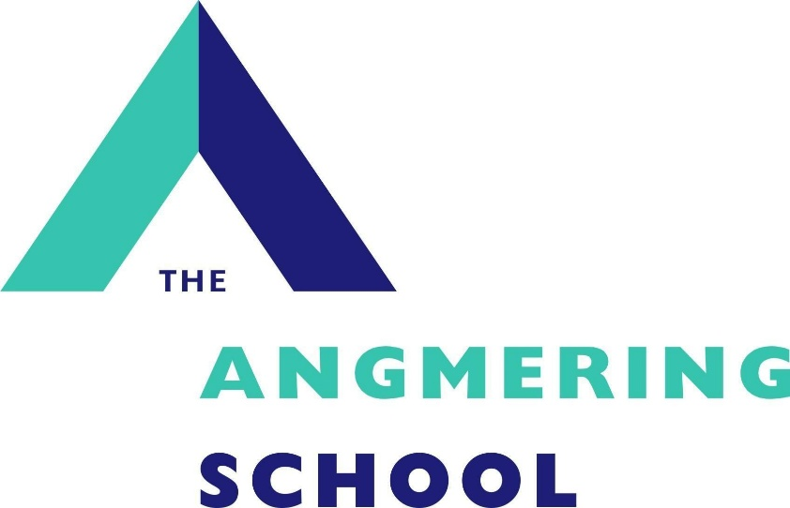

Casual Cover Supervisor Recruitment Pack

April 2026

Dear Applicant,
Thank you for your interest in this vacancy and for requesting an information pack. We hope you find the information useful. Please refer to our school website which gives further detail about our school. Please read the requirements for the application process as carefully as possible and ensure that, if you decide to submit an application, you do not omit any elements. It is essential that you use the section on page 4 of the application form to clearly demonstrate how any experience is relevant to the role and how you meet the person specification. If you would like to visit our school to get a better feel of how we operate please contact the school office to make an appointment.
We look forward to meeting you.
Yours sincerely,
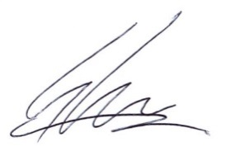
Simon Liley
Headteacher

CASUAL COVER SUPERVISOR
Casual Cover Supervisor required as soon as possible.
Salary: Grade 5, £26,403 (pro rata approx. £19,980 per annum)
Working hours: 6.5 hours per day as required, 8.30am-3.30pm with a 30-minute unpaid lunch break.
Closing date: Friday 24th April 2026
We reserve the right to close the vacancy before the closing date, so please apply early
Interview date: Wednesday 29th April 2026

Are you considering teaching as a possible career, but not sure it is right for you? Do you enjoy working with children?

Then why not consider becoming a Cover Supervisor to gain experience in the classroom. We are looking to appoint a cover supervisor to cover teachers during periods of absence. The key role of a cover supervisor is to work closely with our students across a range of subjects and to ensure they maintain their learning in the absence of their regular teacher. We are looking for candidates with strong organisational and interpersonal skills, who are confident, inspiring and who can make a real difference for students in the classroom. All training will be provided and an opportunity to shadow an experienced colleague will form part of your induction.
‘Staff are enthusiastic about working at the school. They are also very positive about leaders’ attention to their well-being. Leaders are considerate of staff workload.’ – Ofsted report 2022
We can offer you:
- A supportive and strong team, which recognises the importance of staff wellbeing.
- A school that has a special support centre for students with physical and sensory needs.

We are looking for:
- Someone to work as a supervisor of our students in the absence of their normal teacher (training will be given).
- Someone who can adapt to other roles, such as administration support, mentoring, departmental support and help with exams.
- Good communication skills and the ability to provide a safe and productive working environment.
- Someone who maintains good behaviour throughout the lessons across a wide range of subjects.
- A flexible and responsive individual who can manage changes in plans on a regular basis.
- Someone with good communication skills and the ability to provide a safe and productive working environment.
- A team player who enjoys a challenge.
- The willingness to be an educator of our students.

All cover work for students is set up in advance and cover supervisors will work within a strong team of experienced colleagues, who provide a constant source of support.
Please see our website for an application form and further details.
THE ANGMERING SCHOOL, STATION ROAD, West Sussex, BN16 4HH Tel. 01903 772351 Fax 01903 850752
e-mail recruitment@theangmeringschool.co.uk website www.angmeringschool.co.uk
The Angmering School is committed to safeguarding and promoting the welfare of children and young people and expects all staff and volunteers to share this commitment. . The post is subject to a Criminal Records Check. Only completion of all appropriate forms will be considered for short listing. In light of potentially high volume of applicants, you will only be contacted if successfully invited to interview.

JOB DESCRIPTION
Job Title: Cover Supervisor
Start Date: As soon as possible
Accountable to: Lead Cover Supervisor
Hours: 6.5 hours per day as required, 8.30am-3.30pm with a 30-minute unpaid lunch break.

Job Purpose:
- The primary focus of this post is to provide cover in the classroom for absent teachers
- To promote the ethos and good reputation of the school, ensuring effective communication both internally and externally.
- To support the progress of students.

About The Angmering School:
The Angmering School is a secondary school with 1,388 students of which 138 are in sixth form. We are a school that has a special support centre for students with physical and sensory needs. We are effective in delivering outcomes that provide well for all students’ needs. Students are well prepared for the next stage of their education, training or employment.

Main Duties to include:
- Receive and register the class using school systems
- Maintain good order in the classroom in relation to behaviour management
- Communicate the work set by the class teacher to students
- Oversee the using of books and equipment
- Assist students where necessary, using sound judgement to differentiate tasks if required and to seek appropriate assistance for the students when necessary
- Keep students focused and on task by continual monitoring
- Maintain health and safety of students and self in the classroom
- Oversee the collection of books and materials and the end of the lesson and return to the appropriate place
- Ensure the classroom is left in good order
- Return student work to the class teacher
- Complete all relevant paperwork/record an accurate record of events and behaviour
- Share any concerns with the Lead Cover Supervisor
- Attend team meetings
- To provide support and assistance to other areas of the school where needed
General Office Duties:
- Provide back-up in case of colleague absence and other duties as directed by the Lead Cover Supervisor
- Support other departments in areas such as attendance registers, exams, mentoring, administration and reception duties
Health and Safety:
- To be alert to the health and safety of the working environment and to advise the line manager of any health and safety concerns.

This job description is intended to convey information essential to understanding the scope of the job and the general nature and level of work performed by job holders within this role. It is not intended to be an exhaustive list of skills, efforts, or duties, associated with the position. There may be a requirement to undertake other duties reasonably required by the line manager/Head Teacher provided the task is commensurate with the post holder’s core skill competencies, knowledge and experience in the role.

This job profile recognises the demands of the current Pay and Conditions Regulations and reflects the policies established by the governors at The Angmering School.

Person Specification

Key areas: | Key attributes: | Essential or Desirable
Skills required | - Experience of supervising classes in a secondary school (training is given to all successful applicants)  - Demonstrate a friendly but firm manner in the classroom  - Have good interpersonal and communication skills  - Be self-confident in dealing with young people  - Have an awareness of professional boundaries in the work place | Desirable  Essential  Essential  Essential  Essential
Experience | - Working with adults and students.  - Have an awareness of Health & Safety in the workplace. | Desirable  Desirable
Attitude & Approach | - Professional and approachable attitude.  - Enthusiastic in all aspects of work and training.  - Attention to detail.  - Motivated.  - Reliable & punctual.  - Well presented.  - Assertive when appropriate.  - Ability to work in an extremely busy environment whilst keeping a smile on your face. | Essential  Essential  Essential  Essential  Essential  Essential  Essential  Essential

This job description is intended to convey information essential to understanding the scope of the job and the general nature and level of work performed by job holders within this role. It is not intended to be an exhaustive list of skills, efforts, or duties, associated with the position. There may be a requirement to undertake other duties reasonably required by the line manager/Head Teacher provided the task is commensurate with the post holder’s core skill competencies, knowledge and experience in the role.

Safer Recruitment
In complying with current employment legislation, schools are now required, as part of their shortlisting process, to carry out an online search as part of their due diligence.
If you are successfully shortlisted for any roles, an appropriate online search will be undertaken on your name. Information highlighted will be treated as confidential and will only be used in relation to the post for which you have applied.
All successful applicants will be required to undergo full safeguarding and vetting checks, including references and an enhanced Disclosure and Barring Service check, along with a relevant probationary period.

