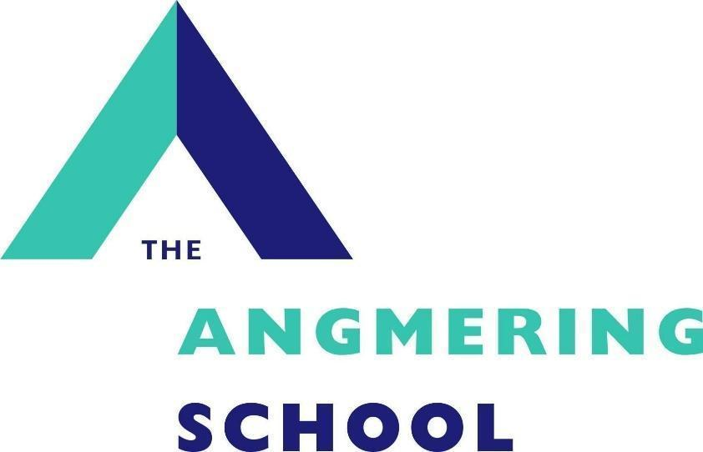

Administrator Resources Assistant

Recruitment Pack

October 2026

Dear Applicant,
Thank you for your interest in this vacancy and for requesting an information pack. We hope you find the information useful. Please refer to our school website which gives further detail about our school. Please read the requirements for the application process as carefully as possible and ensure that, if you decide to submit an application, you do not omit any elements. It is essential that you use the section on page 4 of the application form to clearly demonstrate how any experience is relevant to the role and how you meet the person specification. If you would like to visit our school to get a better feel for how we operate please contact the school office to make an appointment.
We look forward to meeting you.
Yours sincerely,

Simon Liley
Headteacher

ADMIN RESOURCES ASSISTANT
Permanent FTE October 2026

Salary: Grade 4, £24,790 per annum (pro rata approx. £21,357 per annum)
Hours: 37 hours per week 8am-4.30pm Monday-Thursday, 8am-4pm Friday
(with a 1hr unpaid lunch break)
Term Time Only, plus INSET days
Closing date: Sunday 1st November 2026
Interview date: Thursday 5th November 2026

‘Staff are enthusiastic about working at the school. They are also very positive about leaders’ attention to their well-being. Leaders are considerate of staff workload.’ – Ofsted report 2022

We can offer you:
- A supportive and strong team, which recognises the importance of staff wellbeing
- Ongoing support with continuing professional development to enhance staff expertise
- A school with good transport links

We are looking for someone who:
- Is enthusiastic, proactive, resilient and resourceful
- Can provide an excellent front of house service
- Can provide administrative support for the various departments across the school
- Can assist with student attendance when required
- Can man the medical room and provide first aid on a rota basis
- Can provide trips and visits support for the various departments across the school
- Presents a professional image in terms of dress code and attitude
- Promotes the ethos and good reputation of the school, ensuring effective communication both internally and externally
- Has good communication and organisational skills and the ability to provide a safe and productive working environment
- Is a flexible and responsive individual
What we expect from you is:
- Good communication skills
- Excellent use of ICT
- Flexibility and ability to respond to changes in plans rapidly
- A minimum of 5 GCSE passes A to C, including English and Maths
- A strong team player

Please see our website for an application form and further details.
THE ANGMERING SCHOOL, STATION ROAD, West Sussex, BN16 4HH Tel. 01903 772351 Fax 01903 850752
e-mail recruitment@theangmeringschool.co.uk website www.angmeringschool.co.uk
The Angmering School is committed to safeguarding and promoting the welfare of children and young people and expects all staff and volunteers to share this commitment. . The post is subject to a Criminal Records Check. Only completion of all appropriate forms will be considered for short listing.

JOB DESCRIPTION
Job Title: Admin Resources Assistant
Accountable to: Admin Resources Team Leader
Hours: 37 hours per week 8am – 4:30pm Monday-Thursday and 8am-4pm on a Friday (with a 1hr unpaid lunch break)
Term Time Only, plus INSET days
Salary: Grade 4 £26,427 per annum (pro rata approx. £22,767 per annum)

Job Purpose:
- To provide administrative support for the various departments across the school
- To provide trips & visits support for the various departments across the school
- To act as the first point of contact for visitors, parents, pupils, staff and external agencies, providing a welcoming, professional and helpful first impression
- To provide support with the organisation of meetings, appointments, school events and other administrative activities.
- To support the administration of pupil sign-in and sign-out procedures, ensuring that relevant safeguarding requirements are followed.
- To present a professional image in terms of dress code and attitude
- To promote the ethos and good reputation of the school, ensuring effective communication both internally and externally.

About The Angmering School:
The Angmering School is a secondary school with 1,449 students of which 171 are in sixth form. We are effective in delivering outcomes that provide well for all students’ needs. Students are well prepared for the next stage of their education, training or employment.

Main Duties to include:
DEPARTMENT SUPPORT
- To provide effective administrative support to the Headteacher, senior leadership team, teaching staff and wider school departments.
- Assist with the day-to-day administrative and organisational requirements of the school.
- Assist with the organisation of school led meetings such as Open Mornings, Open Evenings, Parents Consultation evenings.
- Supporting staff in organising meetings, events and enrichment activities.
TRIPS & VISITS SUPPORT
- Provide administrative support for the planning and organisation of educational visits, school trips, sporting events and other off-site activities.
- Assist with the preparation and distribution of letters, consent forms, itineraries, information packs and other trip-related documentation.
- Record and monitor parental consent forms, pupil participation and the receipt of required information and payments, in accordance with school procedures.
- Liaise with teaching staff, parents and external providers regarding trip arrangements, deadlines and routine enquiries.
- Assist with booking transport, venues, tickets and other resources as directed.
- Maintain accurate records of pupil attendance, participant lists, emergency contact details and relevant medical or dietary information, ensuring information is handled confidentially.
- Support the collection, checking and organisation of documentation required for educational visits, in line with the school's educational visits policy and procedures.
- Assist with the preparation of staff and pupil lists, registers and other paperwork required before departure and on return.
- Update relevant school systems and maintain organised records of trips, visits and associated documentation.
- Report outstanding documentation, payments or other issues to the relevant member of staff.
- Provide general administrative support to staff coordinating educational visits, ensuring that agreed deadlines and procedures are followed.
ADMIN SUPPORT

- Assist with the provision of hospitality as appropriate.
- Support the administration of pupil sign-in and sign-out procedures, ensuring that relevant safeguarding requirements are followed.
- Prepare, format, photocopy, scan, file and distribute letters, reports, meeting papers, presentations and other school documentation.
- Manage incoming and outgoing correspondence, emails, telephone messages and general enquiries, ensuring these are directed to the appropriate staff member.
- Maintain accurate electronic and paper-based records
- Assist with ordering stationery and resources, monitoring stock levels and maintaining appropriate records of supplies and deliveries.
- Support the administration of school resources, room bookings, equipment and facilities as required.
- Receive, record and distribute deliveries, post, parcels and school resources.
- Maintain confidentiality and ensure that personal and sensitive information is handled securely and in accordance with data protection requirements.
- Follow school policies and procedures relating to safeguarding, health and safety, security and information management.
- Respond flexibly to changing priorities and undertake other reasonable administrative duties appropriate to the role, supporting the smooth and efficient running of the school.

This job description is intended to convey information essential to understanding the scope of the job and the general nature and level of work performed by job holders within this role. It is not intended to be an exhaustive list of skills, efforts, or duties, associated with the position. There may be a requirement to undertake other duties reasonably required by the line manager/Head Teacher provided the task is commensurate with the post holder’s core skill competencies, knowledge and experience in the role.

This job profile recognises the demands of the current Pay and Conditions Regulations and reflects the policies established by the governors at The Angmering School.

Key areas: | Key attributes: | Essential or Desirable
Skills and Approach | - A professional, approachable and helpful manner.  - Good organisational skills, with the ability to prioritise tasks and manage interruptions.  - The ability to maintain confidentiality and handle sensitive information appropriately.  - The ability to work independently and as part of a team.  - Ability to work in an extremely busy environment  - An understanding of the importance of safeguarding, pupil welfare and school security, with a commitment to following school procedures. | Essential  Essential  Essential  Essential  Essential  Essential
Knowledge Base | - Experience of using Google Suite.  - Competent IT skills  - Familiarity with school management systems, such as SIMS, Arbor or Bromcom. | Desirable  Desirable  Desirable  Desirable
Qualifications | - Educated to GCSE standard in Maths and English. | Essential
Experience | - Experience of working within school or other educational settings.  - Previous experience in an administrative, reception or customer service role. | Desirable  Desirable

Safer Recruitment
In complying with current employment legislation, schools are now required, as part of their shortlisting process, to carry out an online search as part of their due diligence.
If you are successfully shortlisted for any roles, an appropriate online search will be undertaken on your name. Information highlighted will be treated as confidential and will only be used in relation to the post for which you have applied.
All successful applicants will be required to undergo full safeguarding and vetting checks, including references and an enhanced Disclosure and Barring Service check, along with a relevant probationary period.

