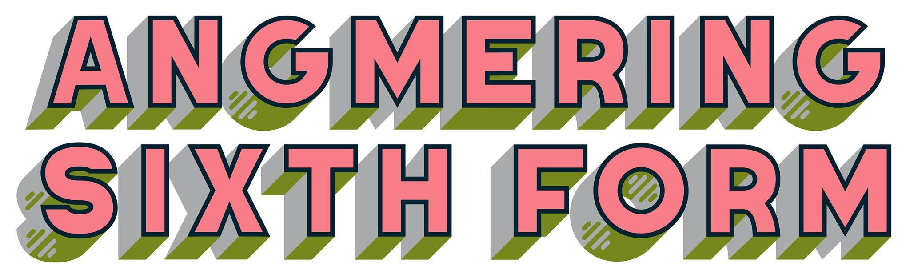
Our Ref: PS059/22-23
7 November 2022

Dear Parent/Guardian

Year 13 History trip to London Imperial War Museum

I am delighted to give you details of a Year 13 History trip that we are organising on Thursday 15th December 2022.

We will be travelling by train departing Angmering at 09.22 to London Victoria and then by tube to the Imperial War Museum, Lambeth Road, London to visit the Holocaust Exhibition. This will enhance students' understanding of this topic.

We will then travel by tube to Soho/Broadwick Street to visit the Broad Street pump. This was the site of a severe outbreak of cholera in 1854.

We will have lunch either at the Imperial War Museum or closer to Soho/Broadwick Street.

We will then walk (approx 35 minutes) from here back to London Victoria to catch the train back to Angmering at 16.05 arriving Angmering at 17.43.

Entrance to the museum is free but students will need to pay for their travel to and from London. Having spoken to the class it was decided that students can buy these by themselves as it will be cheaper for the class to get a group save and avoid the parent pay fee on this occasion.

Students will need to bring either a packed lunch or money to buy lunch and a coat in case of rain, and should wear suitable footwear.
If you give consent for your child to go on this trip please return the consent form below to me by 1st December 2022
Students are expected to abide by our School’s Code of Conduct for the trip, a copy of which is attached. Any students found not to be adhering to the Code of Conduct, could jeopardise their place on the trip and participation in future trips.
.
Yours sincerely

Leanne Kelly

History Lead/Trip Leader
lkelly@theangmeringschool.co.uk

I give consent for …………………………………………………… to travel to London on

Thursday 15th December 2022 to visit the Holocaust Exhibition at the Imperial War

Museum and then a visit to the Broad Street Pump in Soho, London.

Signed:........................................................................................................................

Relation to student:....................................................................................................

